Name: Fabian Ortiz

Chapter 2, Problem 19a

|  |  |
| --- | --- |
| **MEAN** | **MEAN** |
| 29.1 | 17.2 |
| **MEDIAN** | **MEDIAN** |
| 23.5 | 13.5 |

Chapter 2, Problem 19b

|  |  |
| --- | --- |
| **VARIANCE** | **VARIANCE** |
| 275.6555556 | 86.17777778 |
| **STANDARD DEVIATION** | **STANDARD DEVIATION** |
| 16.60287793 | 9.283198682 |

Chapter 2, Problem 19c

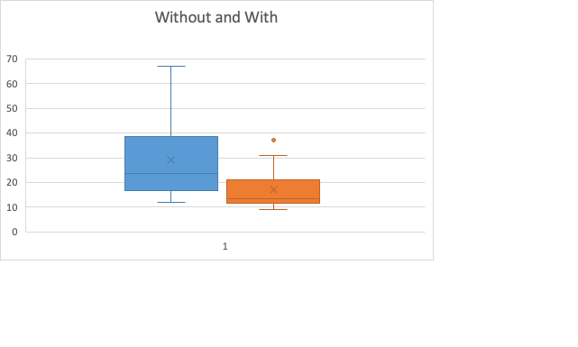

Chapter 2, Problem 19d

No , it doesn’t as the z score isn’t greater or less than -3 or3

|  |
| --- |
| **Z-SCORE** |
| 1.022222222 |

Chapter 2, Problem 19e

Yes, the mean of time of waiting with a tracking system is 17.2 while wait time without a tracking system is 29.1. A factor that could play a part in this is having a tracking system, but it could also depend on the place where this place is located. In heavily populated places where low income people live, there is no tracking system while in places where it is more suburbs, you see wait times more common and less wait time.

Chapter 2, Problem 21a

0.336170213

Chapter 2, Problem 21b

1.466666667

The z score is higher in this data point.

Chapter 2, Problem 21c (Are there any outliers for wait-tracking? Without wait-tracking?)

There appears to be no outliers as none of the data points from the Z-Score are greater or less than -3,+3 according to the empirical rule.